**EDS practical no3(numpy)**

**NAME : Vaibhav Gawali**

**Roll no: 814**

**BATCH : H1**

**PRN no : 202201070075**

import numpy as np array1=np.array([[1,2,3],[4,5,6],[7,8,9]]) array1

## Output -

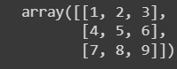

array2=np.array([[11,12,13],[14,15,16],[17,18,19]]) array2

## Output -

# 1. Matrix Operation

|  |
| --- |
| **1.1 Addition** |
| resultarray=array1+array2 print("\nUsing Operator:\n",resultarray) resultarray=np.add(array1,array2) print("\nUsing Numpy Function:\n",resultarray) |

## Output -

|  |
| --- |
| **1.2. Subtraction** |
| resultarray=array1-array2 print("\nUsing Operator:\n",resultarray) resultarray=np.subtract(array1,array2) print("\nUsing Numpy Function:\n",resultarray) |

## Output -

|  |
| --- |
| **1.3. Multiplication** |
| resultarray=array1*array2 print("\nUsing Operator:\n",resultarray) resultarray=np.multiply(array1,array2) print("\nUsing Numpy Function:\n",resultarray) |

## Output –

|  |
| --- |
| **1.4. Division** |
| resultarray=array1/array2 print("\nUsing Operator:\n",resultarray) resultarray=np.divide(array1,array2) print("\nUsing Numpy Function:\n",resultarray) |

## Output –

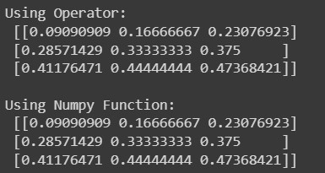

|  |
| --- |
| **1.5. Mod** |
| resultarray=array1%array2 print("\nUsing Operator:\n",resultarray) resultarray=np.mod(array1,array2) print("\nUsing Numpy Function:\n",resultarray |

## Output –

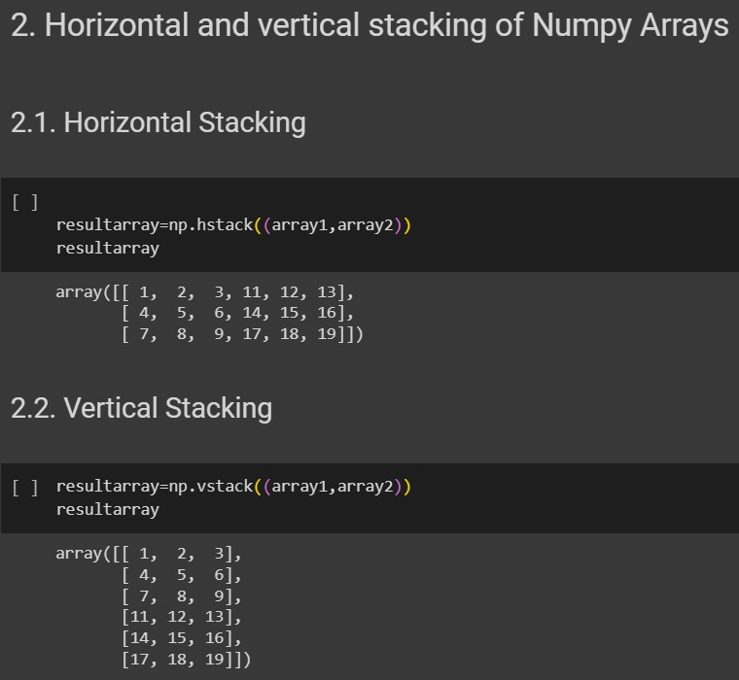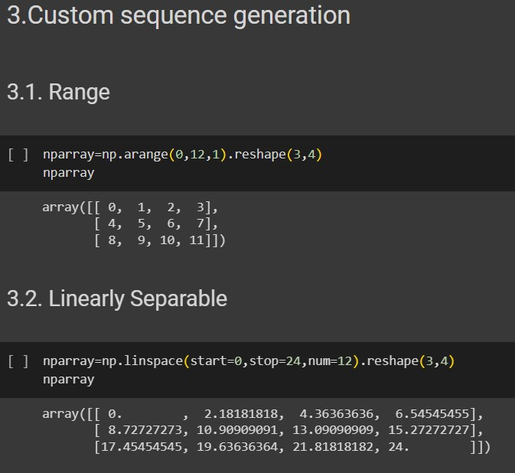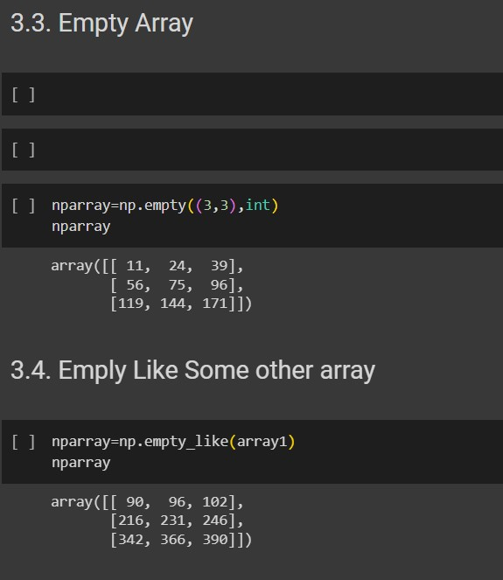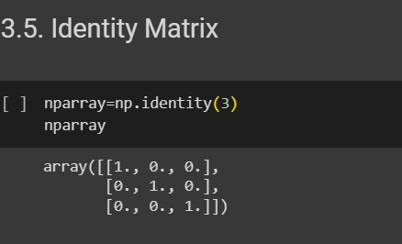

# 4. Arithmetic and Statistical Operations, Mathematical Operations, Bitwise Operators

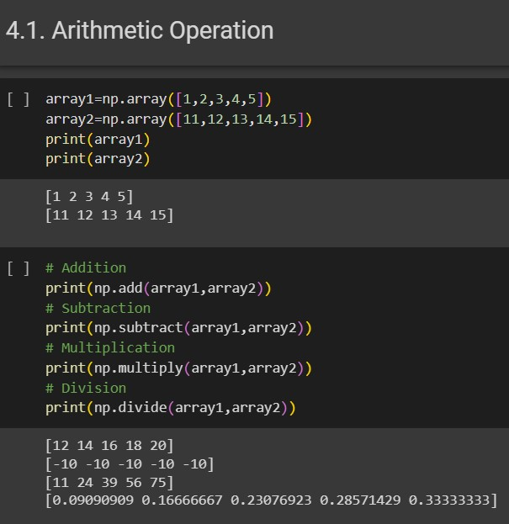

## 5.Copying and viewing arrays



